Name__Evan Cummings__________

- The following tree was built using the UPGMA approach utilizing the provided matrix. What are the following distances as calculated during the tree build:
A—CD 5.5 B—CD 6.5 AB—CD (3+5.5)/2 = 4.25 .
A
B
C
D
 | A | B | C | D
A | 0 | 3 | 5 | 6
B |  | 0 | 6 | 7
C |  |  | 0 | 3
D |  |  |  | 0

 | A | B | CD
A | 0 | 3 | 5.5
B |  | 0 | 6.5
C |  |  | 0
D

Describe the above tree in nested parenthesis notation ((A,B),(C,D)) .

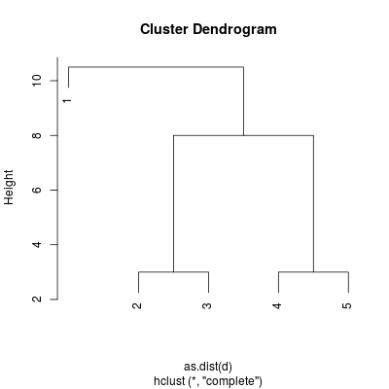
Using the UPGMA approach, build the dendrogram associated with the following distance matrix. Feel free to use R. You can paste the dendrogram into this document. There are no special formatting requirements (i.e. margins, etc.)
 | 1 | 2 | 3 | 4 | 5
1 | 0 | 9.5 | 10.5 | 9.5 | 10.5
2 |  | 0 | 3 | 6 | 7
3 |  |  | 0 | 7 | 8
4 |  |  |  | 0 | 3
5 |  |  |  |  | 0

 | 1 | 2 | 3 | 4-5
1 | 0 | 9.5 | 10.5 | 10
2 |  | 0 | 3 | 6.5
3 |  |  | 0 | 7.5
4 |  |  |  | 0
5

Nested parenthetic : (1, ((2,3),(4,5)))

- Write an R script that generates 10,000 datasets randomly distributed in the Iris dataset vector space (uniform random; i.e. each random vector is randomly generated using a uniform random distribution for each dimension with the range of the minimum and maximum values found in that dimension). Calculate the Cophenetic Correlation Coefficient (CPCC) for each random dataset. Calculate the CPCC for the Iris data itself and indicate how likely it is that a random dataset could generate such a score.
Insert the code of the R script here followed by the p-value generated (the probability that a random dataset would yield the CPCC of the Iris data).

The actual data gives a CPCC val of 0.8769561.
averaging the p-values for all the 10000 uniformly-distributed data results in an `average' p-value of ~0.6518383. While being about 75% the size of the actual data p-value, the random p-value is large enough to suggest that the clusters determined for the real data may not be significant.

Source code:
# store the iris 'classes' :
c = iris[,5]

# store the iris 'data' :
d = iris[,seq(1,4)]
m = as.matrix(d)

cmin = apply(m, 2, min)
cmax = apply(m, 2, max)

CPCC = 0.0

for (i in seq(1:10000))
{
c1 = runif(150, min=cmin[1], max=cmax[1])
c2 = runif(150, min=cmin[2], max=cmax[2])
c3 = runif(150, min=cmin[3], max=cmax[3])
c4 = runif(150, min=cmin[4], max=cmax[4])

C = cbind(c1,c2,c3,c4)
DC1 = dist(C)
hC = hclust(DC1, 'ave')
DC2 = cophenetic(hC)

CPCC = CPCC + cor(DC1, DC2)
}

CPCC = CPCC / 10000

D1 = dist(m)
hc = hclust(D1, 'ave')
D2 = cophenetic(hc)

dataCPCC = cor(D1,D2)

